**Increasing evapotranspiration results in decoupling of vegetation responses to warming in the Tibetan Plateau**

Xue Dai, Zhongbo Yu*

**Abstract**

Plant growth often responds positively to increase in ambient temperature. Hence, most earth system models estimate a continued increase in vegetation cover in future due to elevated temperatures. Here, using two satellite-derived proxies of vegetation cover during 1982–2020, we found that the mid-vegetated (or moderately vegetated) alpine ecosystem in the Tibetan Plateau has significantly degraded in the last 40 years that have witnessed a notable increase in temperature. The observed temperature response curves of vegetation revealed that the positive vegetation-temperature relationships in the high- and low-vegetated areas were reversed in the mid-vegetated area. Structural equation modelling (SEM) revealed that a warmer temperature stimulated evapotranspiration and increased water consumption of an ecosystem (warming to drought, *r∂* = 0.34) in degrading areas. This, in turn, significantly reduced soil water content (drought to water availability, *r∂* = −0.68), which reduced water availability and limited vegetation growth. However, this impact of warming was only observed in the mid-vegetated areas of the Tibetan Plateau because plant transpiration in this region tends to have higher sensitivity to water availability changes than the high-vegetated areas and results in higher increase in total water consumption than that in the low-vegetated area. These findings emphasise the risk of vegetation degradation in mid-vegetated areas under elevated temperatures in the Tibetan Plateau and highlight the central role of plant transpiration in regulating the intensity water availability stress on vegetation prediction under elevated temperatures.

**Introduction**

Previous in situ studies have documented a strong positive relationship between vegetation cover and growing season temperature1-3. This relationship can be interpreted as an increase in photosynthesis in response to warmer climate conditions through many ways, such as photosynthesis-related biochemical processes (such as enzymatic reaction rates) and photosynthesis-related biophysical processes (such as CO2 and water exchange between the leaf and the atmospheric)4-6. It is one of the most accepted hypotheses in ecology that higher temperature during the growing season promotes plant growth. This hypothesis has been directly incorporated into various terrestrial ecosystem models that have variants to account for acclimation, that is, a temporal adjustment of optimum photosynthetic temperature to air temperature during growth2,7,8. Several vegetation studies have further validated this hypothesis with remote sensing techniques and have observed significant greening tendencies of terrestrial ecosystems, especially in the northern high latitudes9,10. Some studies partly attribute these changes to variations in the atmospheric composition, such as CO2 fertilisation effect11,12, nitrogen deposition13,14, aerosol increase,15 or ozone hole10, and intensified human land management, such as afforestation in China and intensive farming in India13,16-18. However, global warming is one of the main reasons for the rejuvenation of terrestrial vegetation10,19–21

As a consequence of obtaining a positive relationship between temperature and vegetation, most ecosystem models predict that ecosystems will continue to accumulate vegetation in a warmer world11,22. However, some regional case studies have recently found a decoupling (or divergence) in the relationship between vegetation growth and warming6,23-25. For example, D’Arrigo et al.26 reported a decline in the temperature sensitivity of tree growth, based on the tree-ring time series, during the late twentieth century. Sanders-DeMott et al.27 revealed that the strength (correlation) of linkage between vegetation productivity and the temperature has declined from the early 1980s to 2011 in the northern hemisphere. Some studies even found non-linear relationships (similar to Gaussian relationships) between vegetation and temperature, implying that plant productivity increases with temperature up to a certain extent and decreases thereafter28,29. These decoupling phenomena suggest that the hypothesis of a positive linear relationship between vegetation and temperature may overestimate the response of vegetation to climate warming and may even draw wrong predictions for some degraded or browning areas.

The mechanism underlying this decoupling is unclear10. One classic hypothesis suggests that plant response to temperature rise is only sensitive for a short time, and with improvement in the adaptability of plants to temperature rise, their sensitivity to temperature rise also decreases30,31. The resource limitation hypothesis proposes that the decoupling response of vegetation depends on the interaction of multiple environmental resources and the response-ability of plants decreases with the consumption of resources5,32-34. Since water is one of the most important resources for plant growth, some studies have tried to explain the decoupling from the aspects of the water transport mechanism of photosynthesis and explore the role of water in regulating plant response to temperature. For instance, Liu et al.35 suggested that elevated temperatures will increase the saturated vapour pressure (VPD) of air, which will result in stomatal closure, inhibiting plant growth. However, many studies argue that soil moisture, and not air humidity, dominates the global ecosystem vegetation under drought stress36.

Using this perspective, we hypothesised that warming reduces water availability (such as soil water content) of the ecosystem by increasing evapotranspiration, thereby inhibiting plant growth and leading to decoupling of vegetation responses to temperature. We tested this hypothesis by investigating changes in vegetation cover on the Tibetan Plateau in the last 40 years (1982–2020) and evaluating the mechanisms underlying the decoupling phenomenon.

**Results and discussion**

**Satellite observation.** We used the vegetation coverage index (VCI, measuring the fractional of vegetated area, Fig. 1a) and leaf area index (LAI, measuring the number of layers of leaves, Fig. 1b) to characterise the vegetation cover of the alpine ecosystem in the Tibetan Plateau and provided the normalised difference vegetation index (NDVI) trends from different datasets as reference (see Fig. S1). Between 1982 and 2020, nearly 89% of the alpine ecosystem of the Tibetan Plateau showed an increasing trend in vegetation cover, with a rate of change of 0.0096 per year for LAI (*p* < 0.0001) and 0.0019 per year for VCI (*p* < 0.001). However, degradation was observed in the remaining 11% of the alpine ecosystem (marked as dark blue and light blue in Fig. 1a and b, respectively), with a significant rate of change (*p* < 0.05) of LAI (*slope* = -0.0026 per year). We noted that vegetation in specific regions of the Tibetan Plateau had degraded even under warm climate and relief from chilling stress. Spatially, this area is located exactly in the middle of the vegetated area of the Tibetan Plateau, as vegetation cover of the Tibetan Plateau generally follows a decreasing pattern toward the northwest according to the terrain gradient (Fig. S2). This finding confirms the existence of divergence in vegetation response to warming in the Tibetan Plateau and reveals its spatial extents.

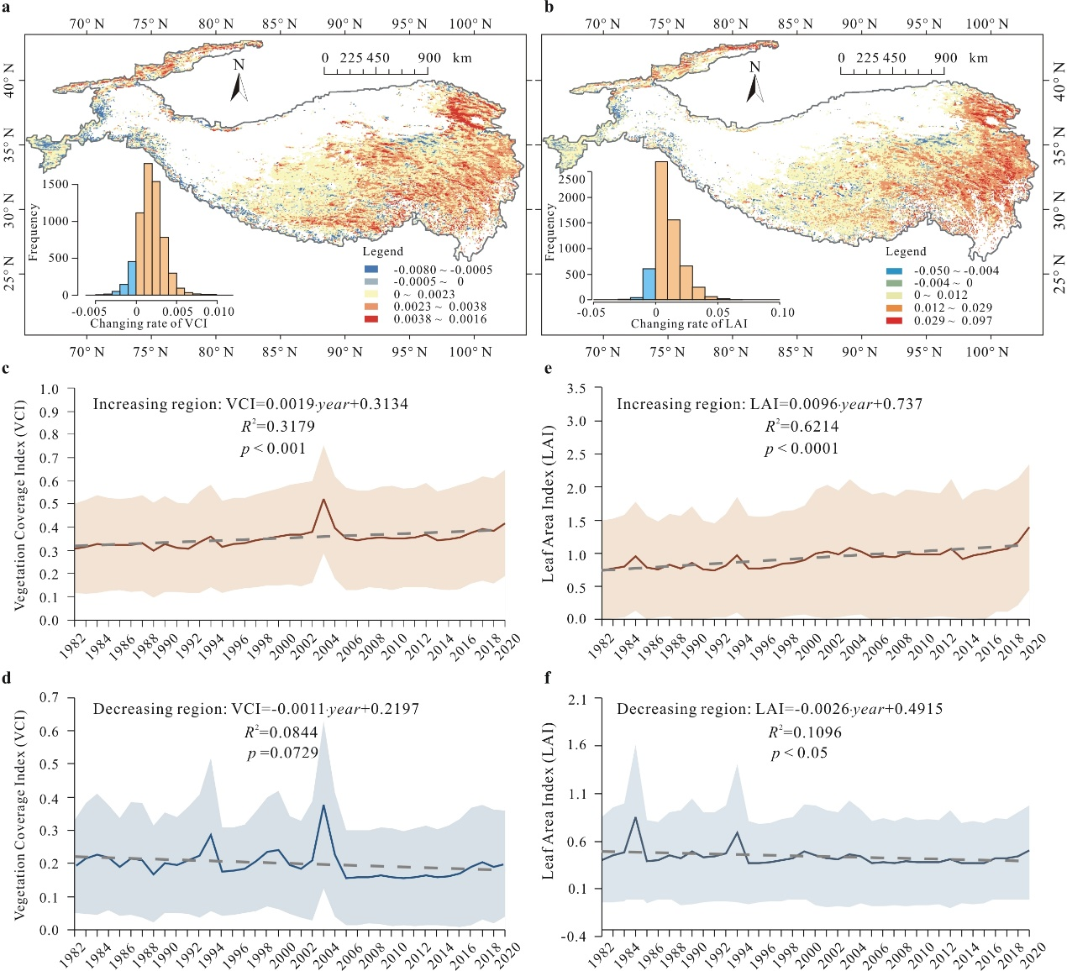

**Figure 1 | Changes in two vegetation cover indices, vegetation coverage index (VCI) and leaf area index (LAI).** **a,** The maximum VCI trend in the growing seasons during 1982–2020. The VCI data are calculated from the advanced very-high-resolution-radiometer (AVHRR) normalised difference vegetation index (NDVI) dataset (see Method 2). **b,** The maximum AVHRR LAI trend in the growing seasons during 1982–2020. The AVHRR LAI dataset is the average of three different products (GIMMS13, GLOBMAP23, and GLASS)41. **c,** **d,** Changes in the maximum VCI in the growing seasons over the regions showing increasing and decreasing vegetation cover during 1982–2020. **e,** **f,** Changes in the maximum LAI in the growing season over the regions showing increasing and decreasing vegetation cover during 1982–2020.

**Temperature response curves of vegetation cover.** To quantify the responses of vegetation cover to temperature, we created the temperature response curves of VCI and LAI in the Tibetan Plateau, as observed in Fig. 2 (see Methods 6). Our findings contradict those of previous studies; vegetation cover in both high-vegetated areas (VCI < 0.42 and LAI < 1.04) and low-vegetated areas (VCI > 0.55 and LAI > 1.54) was positively correlated with the corresponding temperature during the growing season (May to October). However, in the mid-vegetated area (0.42 < VCI < 0.55 and 1.04 < LAI < 1.54), vegetation cover was negatively correlated with the growing-season temperature. Based on the thresholds provided by the turning points of the vegetation-temperature curves, we identified the spatial area where vegetation cover is negatively correlated with temperature (marked in yellow in Figs. 2c and 2d). The yellow-marked areas almost overlay with the degrading vegetation areas depicted in Fig. 1, which implies that the latter reflect the negative response of vegetation to warming. Notably, in our recent field survey in the southeast Tibetan Plateau (May 13 to May 20, 2021), we did observe extensive vegetation of sporadic dead birch (*Betula platyphylla* Suk.) in the mid-vegetated areas (Fig. S3). This observation verified the degrading trend detected by remote sensing in Fig. 1 and decoupling revealed by temperature response curves in Fig. 2.

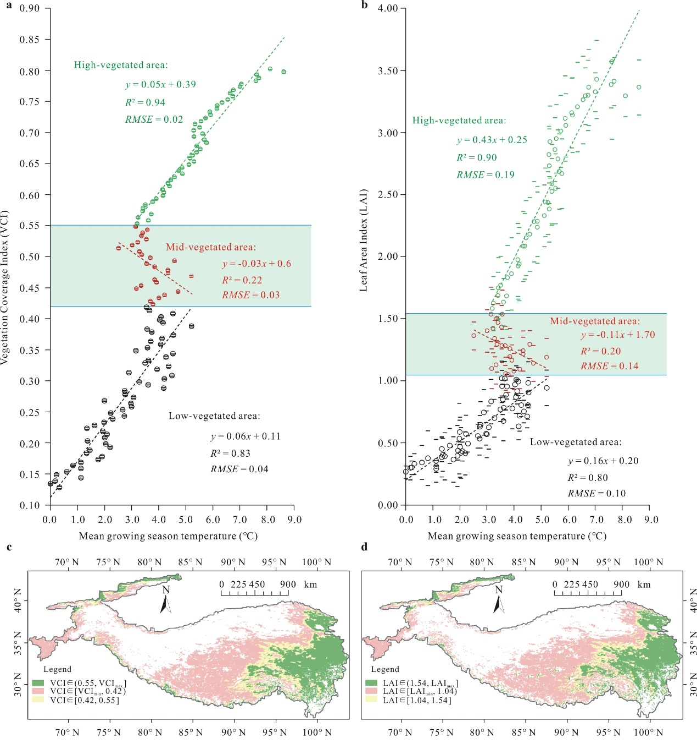

**Figure 2 | Temperature response curves of vegetation cover in the Tibetan Plateau.** **a**, **b**, Temperatures response curves of VCI and LAI, respectively. **c**, **d**, Distribution of vegetation areas in Tibetan Plateau identified using VCI and LAI thresholds shown in **a** and **b**, respectively. Yellow colour depicts regions that show negative relationship with temperature.

**Mechanisms.** To discern the mechanisms underlying the observed decoupling in vegetation response to warming, we established a structural equation meta-model to integrate key predictions on the impacts of water and energy on vegetation into a multi-process hypothesis for evaluation, as shown in Fig. 3a.

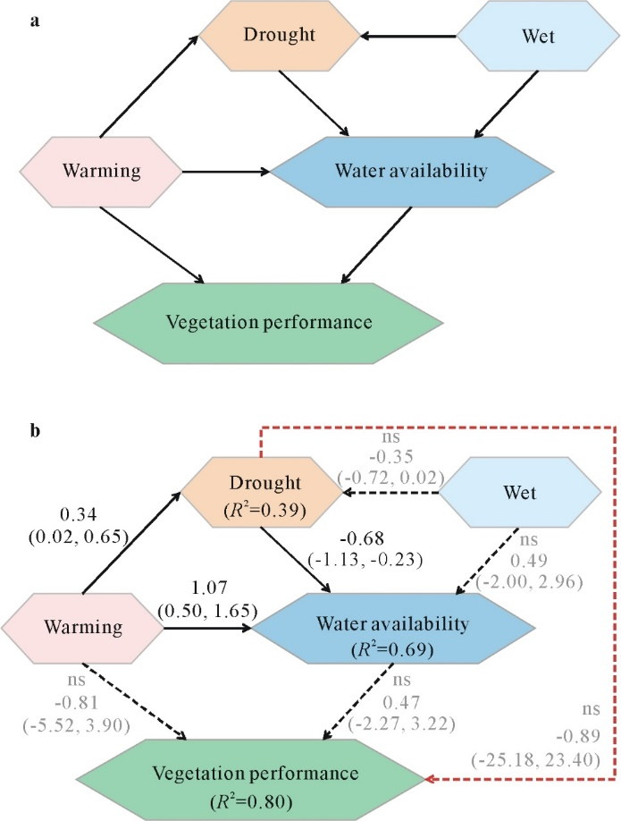

**Figure 3 | Structural equation models of the vegetation degrading areas in the Tibetan Plateau.** **a**, Structural equation meta-model. **b**, Structural equation model supported by the data. Solid arrows represent significant effects (95% credible interval does not include 0), dashed arrows represent non-significant effects (95% credible interval includes 0). The test statistic *MargLogLik* = -102. 02 and *BIC* = 59.01, with 25 model degrees of freedom and *PP* = 0.45 (indicating close model-data fit).

This meta-model assumes that vegetation cover is controlled by warming and water availability of ecosystems. Water availability is further determined by drought, reflecting water consumption of ecosystems via evapotranspiration, and the wet, reflecting the water input of ecosystems via precipitation. As evapotranspiration can be influenced by both warm and wet conditions, we also linked “warming” to drought” and “wet” to “drought” in the meta-model. Further, since snowmelt is an important water source for the Tibetan Plateau ecosystems, we added a linkage from “warming” to “water availability” in the meta-data.

By synthesising remote sensing and reanalysis data from multiple sources (Extended Table 1), we evaluated the meta-model for vegetation degrading areas (see Method 3). Environmental variables included air temperature and soil surface temperature (constituting the latent variable ‘warming’), dewpoint temperature and volumetric soil water (constituting the latent variable ‘water availability’), plant transpiration and soil evaporation (constituting the latent variable ‘drought’), and precipitation and snow depth water equivalent (constituting the latent variable ‘wet’) (Extended Table 2, Fig. S4). The meta-model, along with the collected data, guided the development of a structural equation model for empirical evaluation. We evaluated model-data consistency to determine the presence of missing links in the initial model as well as to support the proposed links. We also assessed the dimensions of the model (i.e., the number of parameters and linkages) required to detect signals in the collected data. For this, we evaluated lower-dimensional versions of the model by removing linkages and re-evaluating against the data. Related data and methodological details are provided in the Methods and Supplementary Information.

Figure 3b is the structural equation model representing the connections between vegetation cover and other water and energy factors supported by the data in the vegetation degrading area. First, we found clear evidence that warming increases drought (standardised path coefficient 0.34; 95% credible interval (CI) [0.02, 0.65]), which decreases water availability (coefficient -0.68; 95% CI [-1.13, -0.23]). Hence, warming has an indirect negative effect on water availability of ecosystems mediated by drought (coefficient -0.23). This finding is consistent with our hypothesis that the negative vegetation-temperature relationship occurs due to increasing water consumption as a consequence of increase in evapotranspiration. However, surprisingly, the effects of both warming (coefficient -0.81, ns) and water availability (coefficient 0.47, ns) on vegetation cover in the mid-vegetated region were non-significant. This is because both temperature and water availability are strong limiting factors of vegetation growth in this area. That is, their interactions dominate the vegetation growth. Hence, our results demonstrate that failure to account for the variation in water availability explained by evapotranspiration would make it difficult to explain the negative influences of warming on vegetation.

We also found that the positive effect of wet variables on water availability was weak (coefficient0.49, ns), whereas that of the warming variable was strong (coefficient1.07; 95% CI [0.50, 1.65]). These findings suggest that snow melting is more important than precipitation for determining the water condition of ecosystems in this area. They also explain why the negative vegetation response to warming is limited to a small part of the Tibetan Plateau. The drying effect of warming on vegetation via increasing evapotranspiration can be partially offset in warmer climates due to an increase in the snowmelt. Besides, compared to the meta-model, the final model indicated a weak but direct inhibiting effect of drought on vegetation cover (coefficient -0.89, ns). It suggests that the drying ecosystem may limit vegetation growth in other ways but they have not been included in the meta-model. We speculate that dry environmental conditions may affect vegetation growth by reducing the availability of soil nutrient conditions or microorganisms. Besides, other local factors, such as elevation, permafrost thickness, soil characteristics, and climate regime changes, may also affect the responses of vegetation to warming. However, the conclusions drawn from the structural equation model by using remote sensing data of the entire plateau were unable to determine the influences and interactions of the abovementioned factors. Additionally, the final model did not make any simplifications in the meta-model because it would fail to detect previously detected pathways and result in a notable loss of signal (as indicated by reduced values of *R*2 in the model).

**Discriminate condition of the negative response of vegetation to temperature.** Since the final SEM emphasised the importance of water availability via evapotranspiration, we further compared the relationship between vegetation cover and variables affecting water availability in the Tibetan Plateau, aiming to reveal the conditions that result in a negative response of the moderately vegetated areas to warming. As the vegetation cover shows a clear decreasing pattern toward the northwest of the Tibetan Plateau, we defined the southeast boundary of the decoupling response region (with vegetation cover states turning from high-vegetated to moderate-vegetated) as the upper boundary of the region and the northwest boundary of the decoupling region (with vegetation cover state changing from moderate-vegetated to low-vegetated) as the lower boundary. As shown in Fig. 4, the upper boundary is next to the saturation point of vegetation response to growing season precipitation (Fig. 4a) and is almost consistent with the turning point of vegetation response to snow water equivalent in the growing season (Fig. 4b). This phenomenon can be interpreted as follows: when water is no longer a limiting factor of vegetation growth, the restraining effect of warming on vegetation, by increasing water consumption via evapotranspiration, would not work. In addition, Fig. 4c and 4d show that the lower boundary of the decoupling response of vegetation to temperature can be seen when soil evaporation begins to decrease as vegetation cover increases. Since soil evaporation decreases with an increase in vegetation cover only in areas with certain vegetation, we reveal that the effect of warming on reducing water availability and inhibiting vegetation growth by increasing evapotranspiration is only possible in areas with certain vegetation coverage but not in areas where soil evaporation is higher than vegetation transpiration in the growing season.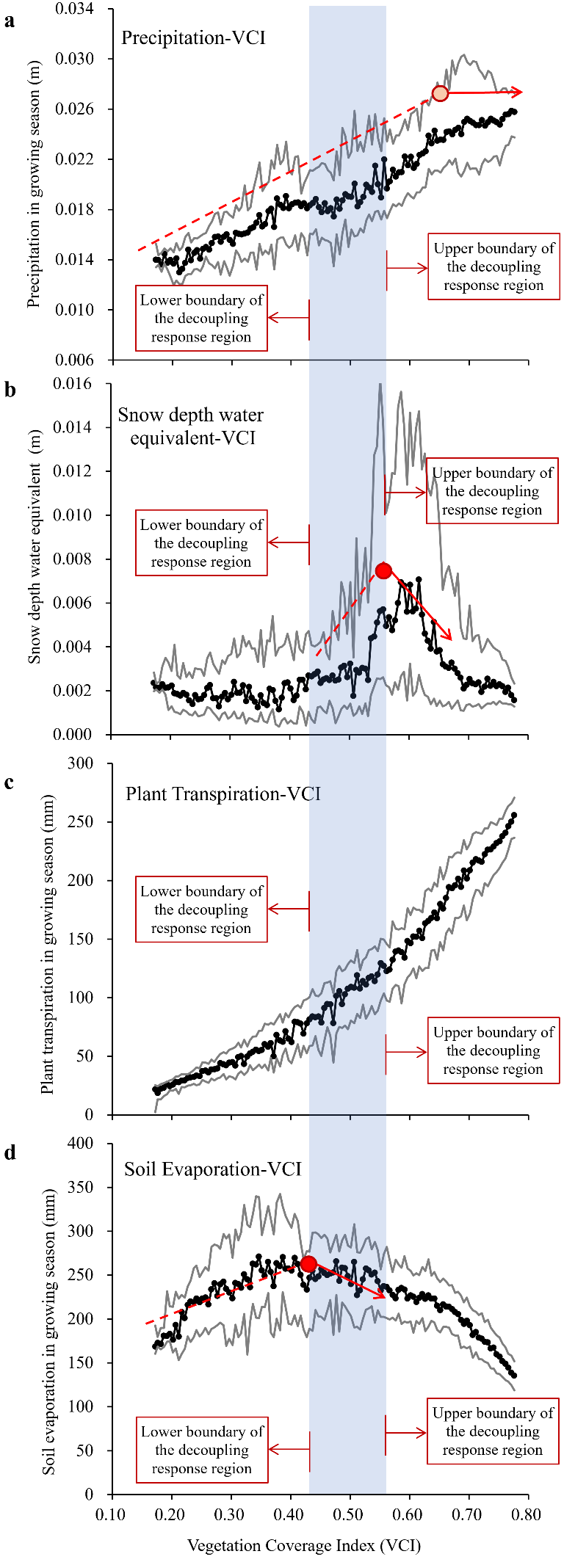

**Figure 4 | The corresponding relationship between the tipping points of VCI response to multiple water variables along with the upper and lower boundaries of areas where vegetation growth responds negatively to warming. a**, Precipitation versus VCI. **b**, Snow depth water equivalent versus VCI. **c**, Plant transpiration versus VCI. **d**, Soil evaporation versus VCI.

**Spatiotemporal variations of the decoupling region and their verification of the discriminate conditions.** According to our observed discriminate conditions of the decoupling regions, their extents should vary with precipitation and evaporation conditions of the plateau in each year. Here, we extracted the boundaries of the decoupling regions in each year (Fig. S6) and checked their consistency with the tipping points of VCI response to precipitation and soil evaporation (Fig. 6), i.e., the discriminate conditions we obtained in the last section. Figure 5a shows the temperature response curves of VCI in each year in the Tibetan Plateau, and the boundaries of the decoupling regions extracted from turning points of these curves. Fig. 5b and 5d further analysed their consistencies with the tipping points of VCI response to precipitation and soil evaporation. It is noted that the lower boundaries of the decoupling region vary a lot in each year, whereas the upper boundaries of the decoupling regions were relatively fixed in different years.

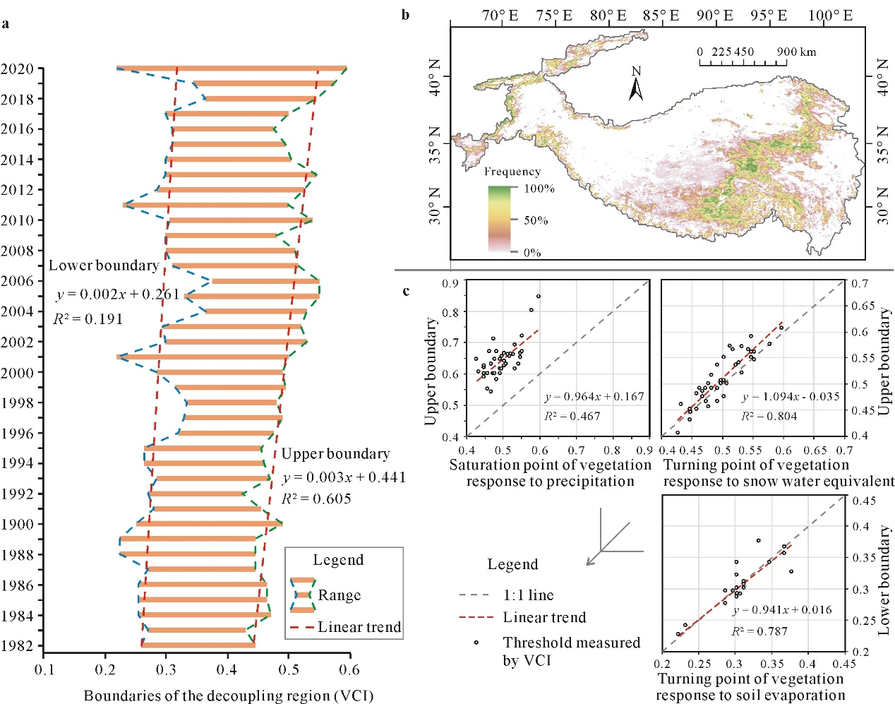

**Figure 5 | Spatiotemporal variations of the decoupling region and the associated tipping points of VCI response to multiple water variables.** **a**, Variations of the boundaries of the decoupling region over the recent 40 years. **b**, Spatial extent changes of the decoupling region expressed by occurring frequency. **c**, The relationships between the decoupling boundary changes and the the turning points changes of VCI response to precipitation, snow water equivalent, and soil evaporation.

The Tibetan Plateau is the largest geographical unit with the highest elevation on Earth that has large ice masses and therefore, it is often called the “Third Pole. The vegetation in this region is vulnerable but provides multiple ecosystem services of local and global importance. In recent decades, the plateau has witnessed more rapid temperature changes than other regions around the globe. This has altered the water and energy interaction patterns in the region that have, in turn, resulted in remarkable changes in the properties and extent of vegetation cover. However, the mechanism and extent of the impact of climate change on alpine vegetation had not been systemically detected. This study is the first to report the degrading tendency and decoupling phenomenon of vegetation response to warming in the moderately vegetated areas of the Tibetan Plateau. We used an integrated SEM to discern the mechanism underlying the decoupling phenomenon and demonstrated that the effect of temperature rise on vegetation growth becomes complex due to the influence of evapotranspiration. The study findings reveal that the terrestrial ecosystem models based on positive correlation hypothesis between temperature and vegetation growth may overestimate the impact of temperature rise on vegetation. They may also underestimate the decline in water resources via evapotranspiration during growing season in semi-arid regions.

We also identified the boundaries of the decoupling phenomenon in the Tibetan Plateau by using multiple water availability-related environmental variables. The saturation point of vegetation response to water availability and the proportion of plant transpiration in the total ecosystem evapotranspiration may be the two boundary conditions controlling the decoupling phenomenon. However, these specific thresholds may only be applicable in alpine ecosystem of the Tibetan Plateau at specific temporal and spatial resolutions. Nonetheless, the study findings emphasise the importance of eco-hydrological processes in mediating vegetation response to climate change. They are important references for improving the land surface models that predict vegetation changes in a warmer world. Further, the vegetation-degradation maps developed in this study can aid planning and prioritisation of the most vulnerable areas for protection and climate change mitigation.

**Methods**

**1. NDVI.** Normalised difference vegetation index (NDVI) is a vegetation index defined as the ratio of the difference between near infra-red and red visible reflectance to their sum and was used to calculate the VCI in this study. Furthermore, to account for uncertainties in the detection of changing trend that arise due to different satellite datasets and different indices, we also checked the changing tendencies in three independent NDVI datasets in this study, as shown in Fig. S1. These included bi-weekly NDVI data from Global Inventory Modeling and Mapping Studies (GIMMS) AVHRR, 16-day NDVI data from terra MODIS and 8-day NDVI Composite data from USGS Landsat TM/OLI products (Landsat 5, Landsat 7, and Landsat 8). The three NDVI datasets spanned three decades: 1982–2020 for AVHRR NDVI datasets, 2000–2020 for MODIS NDVI datasets, and 1984–2020 for Landsat NDVI datasets, with the spatial resolutions of 8 km, 1 km, and 30 m, respectively. The average changing rate of the three NDVI products was also calculated, as shown in Fig. S1d. Only positive NDVI values were used in the analysis.

**2. VCI.** Vegetation condition index (VCI) is an index that can differentiate the green vegetation information and bare soil information on a per-pixel basis and is used for estimating the fractional vegetation coverage. Following Zhang et al. (2020), we used the daily AVHRR NDVI to calculate the daily VCI for 1982–2020 using the following equation:

, (1)

where NDVIsoil is the NDVI value of pure soil pixels, and NDVIveg is the NDVI value of fully vegetated pixels. For the Tibetan Plateau, NDVIsoil was chosen to be the NDVI value in which the cumulative frequency is 0.5% in all pixels and NDVIveg was chosen to be the cumulative frequency of NDVI above 99.5%. The NDVI data were derived from the AVHRR NDVI with a spatial resolution of 0.05 degrees. Again, only positive VCI values were used in the analysis.

**3. LAI.** Leaf area index (LAI) is used for measuring the number of layers of leaves using remote sensing. The LAI data were also derived from the NOAA CDR of AVHRR; only positive LAI values were used in the analysis.

**4. Climate dataset.** Meteorological data collected from multiple sources were used to evaluate the structural equation meta-model. Extended Table 1 summarises the data used in this study and their sources. The meteorological data with different spatial and temporal resolutions were first resampled into the same spatial resolution of 0.05° and averaged in the growing and non-growing season during 2000–2020 (the overlapping time periods for all datasets). The vegetation data, VCI and LAI, were also averaged during 2000–2020 to correspond to the climate data. The contour line of 3000 m in this area was taken as the boundary of the Tibetan Plateau, which was then used to clip all the climate and vegetation maps used in this study.

**5. Structural equation model.** A structural equation model37 was developed based on the ideas embodied in the meta-model, available data, and the principles and procedures laid out by Grace et al.38. Indicators for constructs were chosen from the set of variables available and quantities that could be computed from them (Extended Table 2, Fig. S4). We fit the model in the R package ‘blavaan’ 39, initialising three MCMC chains that each took 25000 samples from the posterior distribution. We ensured that all the variables met the assumptions of normality and homoscedasticity. At each iteration, we estimated each of the *β* parameters and the indirect effect size and net effect size derived by combining path coefficients, discarding the first 5000 samples from each chain as burn-in. We assessed convergence on the target posterior distribution visually (Fig. S5) and by confirming that the Potential Scale Reduction Factor for each parameter40 was 1.001. We estimated the 95% credible interval around each parameter estimate, as well as an empirical *p*-value for each parameter, from the posterior samples. We compared the sizes of the effects of factors such as temperature and water on vegetation cover by comparing standardised coefficients.

**6. Temperature response curve of vegetation cover.** By matching the maps of 2000–2020 averaged vegetation cover indexes (VCI and LAI) and the growing season air temperature pixel by pixel, we obtained the multiyear-averaged VCI-temperature and LAI-temperature record in each pixel. We then generated VCI intervals with a step of 0.005 and used the intervals to divide the VCI- and LAI-temperature records into different groups. The averaged VCI, LAI, and temperature values and their standard deviations were calculated in each group, which were then plotted as the final temperature response curves of vegetation cover indexes.

**Data availability**

All data and R scripts necessary to reproduce the analyses in this manuscript are archived at .

**Acknowledgment**

We would like to thank all the developers of the data sets mentioned in Extended Table 1 for providing data. (基金信息有待添加)

**Author Contributions**

X.D. and Z.Y. conceived the study. X.D. prepared the data, set up the model, and conducted statistical inference, with all the authors providing input. Z.Y. further improved the analysis design. X.D. and Z.Y. led the manuscript writing. All the authors contributed to editing the manuscript.

**Competing Interests statement**

The authors declare no competing interests.

**Supplementary Information**

Further supplementary information of this research is available in the *Nature Climate Change* summary linked to this article.

**References**

1. Berry, J. A. & Bjorkman, O. Photosynthetic response and adaptation to temperature in higher plants. *Ann. Rev. Plant Physiol*. **31**(1), 491–543 (1980). 10.1146/annurev.pp.31.060180.002423.
2. Kattge, J. & Knorr, W. Temperature acclimation in a biochemical model of photosynthesis: a reanalysis of data from 36 species. *Plant Cell Environ.* **30**(9), 1176–1190 (2007). [10.1111/j.1365-3040.2007.01690.x](https://doi.org/10.1111/j.1365-3040.2007.01690.x), Pubmed:[17661754](https://www.ncbi.nlm.nih.gov/pubmed/17661754)
3. Lloyd, J. & Farquhar, G. D. Effects of rising temperatures and [CO2] on the physiology of tropical forest trees. *Phil. Trans. R. Soc. B* **363**(1498), 1811–1817 (2008). [10.1098/rstb.2007.0032](https://doi.org/10.1098/rstb.2007.0032)
4. Medlyn, B. E. et al. Temperature response of parameters of a biochemically based model of photosynthesis. II. A review of experimental data. *Plant Cell Environ.* **25**(9), 1167–1179 (2002). [10.1046/j.1365-3040.2002.00891.x](https://doi.org/10.1046/j.1365-3040.2002.00891.x)
5. Piao, S. L. et al. Evidence for a weakening relationship between interannual temperature variability and northern vegetation activity. *Nat. Commun.* **5**, 5018 (2014). [10.1038/ncomms6018](https://doi.org/10.1038/ncomms6018), Pubmed:[25318638](https://www.ncbi.nlm.nih.gov/pubmed/25318638)
6. Huang, M. T. et al. Air temperature optima of vegetation productivity across global biomes. *Nat. Ecol. Evol.* 3(5), 772–779 (2019). [10.1038/s41559-019-0838-x](https://doi.org/10.1038/s41559-019-0838-x), Pubmed:[30858592](https://www.ncbi.nlm.nih.gov/pubmed/30858592)
7. Smith, N. G., Malyshev, S. L., Shevliakova, E., Kattge, J. & Dukes, J. S. Foliar temperature acclimation reduces simulated carbon sensitivity to climate. *Nat Clim. Change* **6**(4), 407–411 (2016). [10.1038/nclimate2878](https://doi.org/10.1038/nclimate2878)
8. Mercado, L. M. et al. Large sensitivity in land carbon storage due to geographical and temporal variation in the thermal response of photosynthetic capacity. *New Phytol.* **218**(4), 1462–1477 (2018). [10.1111/nph.15100](https://doi.org/10.1111/nph.15100), Pubmed:[29635689](https://www.ncbi.nlm.nih.gov/pubmed/29635689)
9. Myneni, R. B. et al. Increased plant growth in the northern high latitudes from 1981 to 1991. *Nature* 386(6626), 698–702 (1997). [10.1038/386698a0](https://doi.org/10.1038/386698a0)
10. Piao, S. et al. Characteristics, drivers and feedbacks of global greening. *Nat. Rev. Earth Environ.* **1**(1763), 1–14 (2019). 10.1038/s43017-019-0001-x
11. Wang, S. et al. Urban-rural gradients reveal joint control of elevated CO2 and temperature on extended photosynthetic seasons. *Nat. Ecol. Evol.* **3**(7), 1076–1085 (2019). [10.1038/s41559-019-0931-1](https://doi.org/10.1038/s41559-019-0931-1), Pubmed:[31235928](https://www.ncbi.nlm.nih.gov/pubmed/31235928)
12. Wang, S. et al. Recent global decline of CO2 fertilization effects on vegetation photosynthesis. *Science*. **370**(6522), 1295–1300 (2020). 10.1126/science.abb7772
13. Chen, C. et al. China and India lead in greening of the world Through land-use management. *Nat. Sustain.* **2**, 122–129 (2019). [10.1038/s41893-019-0220-7](https://doi.org/10.1038/s41893-019-0220-7), Pubmed:[30778399](https://www.ncbi.nlm.nih.gov/pubmed/30778399)
14. Huntzinger, D. N. et al. Uncertainty in the response of terrestrial carbon sink to environmental drivers undermines carbon-climate feedback predictions. *Sci. Rep*. **7**(1), 4765 (2017). 10.1038/s41598-017-03818-2
15. Wang, X. et al. Field evidences for the positive effects of aerosols on tree growth. *Glob. Chang. Biol.* **24**(10), 4983–4992 (2018). [10.1111/gcb.14339](https://doi.org/10.1111/gcb.14339), Pubmed:[29855126](https://www.ncbi.nlm.nih.gov/pubmed/29855126)
16. Hansen, M. C. et al. High-Resolution Global Maps of 21st-Century Forest Cover Change. *Science* 342(6160), 850–853 (2013). [10.1126/science.1244693](https://doi.org/10.1126/science.1244693), Pubmed:[24233722](https://www.ncbi.nlm.nih.gov/pubmed/24233722)
17. Wolf, J. et al. Biogenic carbon fluxes from global agricultural production and consumption. *Global Biogeochem. Cycles*. **29**(10), 1617–1639 (2016). 10.1002/2015GB005119.
18. Parida, B. R. et al. Greening and browning trends of vegetation in India and their responses to climatic and non-climatic drivers. *Climate* **8**(8), 92 (2020). [10.3390/cli8080092](https://doi.org/10.3390/cli8080092)
19. Zhou, L. et al. Variations in northern vegetation activity inferred from satellite data of vegetation index during 1981 to 1999. *J. Geophys. Res.* 106(D17), 20069–20083 (2001). [10.1029/2000JD000115](https://doi.org/10.1029/2001389)
20. Kaufmann, R. K. et al. Reply to comment on “Variations in northern vegetation activity inferred from satellite data of vegetation index during 1981 to 1999” by J.R. Ahlbeck. *J. Geophys. Res. Atmos.* **106**, 20069–20083 (2001)
21. Loarie, S. R. et al. The velocity of climate change. *Nature* 462(7276), 1052–1055 (2009). [10.1038/nature08649](https://doi.org/10.1038/nature08649), Pubmed:[20033047](https://www.ncbi.nlm.nih.gov/pubmed/20033047)
22. Zhu, Z. et al. Greening of the Earth and its drivers. *Nat. Clim. Change* 6(8), 791–795 (2016). [10.1038/nclimate3004](https://doi.org/10.1038/nclimate3004)
23. Tao, W. et al. Emerging negative impact of warming on summer carbon uptake in northern ecosystems. *Nat. Commun.* **9**(1) (2018). 10.1038/s41467-018-07813-7
24. Piao, S. L. et al. Weakening temperature control on the interannual variations of spring carbon uptake across northern lands. *Nat. Clim. Change*. **7**(5), 359–363 (2017). 10.1038/nclimate3277
25. Liu, D. et al. Contrasting responses of grassland water and carbon exchanges to climate change between Tibetan Plateau and Inner Mongolia. *Agric. Forest Meteorol*. **249**, 163–175 (2018). 10.1016/j.agrformet.2017.11.034
26. D’Arrigo, R. D. et al. Thresholds for warming-induced growth decline at elevational tree line in the Yukon Territory, Canada. *Global Biogeochem. Cycles* **18**(3), GB3021, n/a–n/a (2004). [10.1029/2004GB002249](https://doi.org/10.1029/2004GB002249)
27. Sanders-DeMott, R. et al. Divergent carbon cycle response of forest and grass-dominated northern temperate ecosystems to record winter warming. *Glob. Chang. Biol.* **26**(3), 1519–1531 (2020 Mar). [10.1111/gcb.14850](https://doi.org/10.1111/gcb.14850), PMID: [31553818](http://www.ncbi.nlm.nih.gov/pubmed/31553818)
28. Duffy, K. A. et al. How close are we to the temperature tipping point of the terrestrial biosphere? *Sci. Adv.* **7**(3), eaay1052 (2021 Jan 13). [10.1126/sciadv.aay1052](https://doi.org/10.1126/sciadv.aay1052), PMID: [33523891](http://www.ncbi.nlm.nih.gov/pubmed/33523891), PMCID: [PMC7806211](https://www.ncbi.nlm.nih.gov/pmc/articles/PMC7806211)
29. Chen et al., 2020
30. Fu, Y. H. et al. Declining global warming effects on the phenology of spring leaf unfolding. *Nature* **526**(7571), 104–107 (2015). [10.1038/nature15402](https://doi.org/10.1038/nature15402), Pubmed:[26416746](https://www.ncbi.nlm.nih.gov/pubmed/26416746)
31. Zhao, Q. et al. Future greening of the Earth may not be as large as previously predicted. *Agric. Forest Meteorol.* **292-293** (2020). 10.1016/j.agrformet.2020.108111
32. Angert, A. et al. Drier summers cancel out the CO2 uptake enhancement induced by warmer springs. *Proc. Natl Acad. Sci. U. S. A.* **102**(31), 10823–10827 (2005). [10.1073/pnas.0501647102](https://doi.org/10.1073/pnas.0501647102), Pubmed:[16043702](https://www.ncbi.nlm.nih.gov/pubmed/16043702)
33. Beck, P. S. A. & Goetz, S. J. Satellite observations of high northern latitude vegetation productivity changes between 1982 and 2008: ecological variability and regional differences. *Environ. Res. Lett.* **6** (2011). 10.1088/1748-3182/6/4/[045501](http://www.ncbi.nlm.nih.gov/pubmed/045501)
34. Wu, Z. et al. Biogeochemical and ecological feedbacks in grassland responses to warming. *Nat. Clim. Change* **2**(6), 458–461 (2012). [10.1038/nclimate1486](https://doi.org/10.1038/nclimate1486)
35. Liu, Y. et al. Plant hydraulics accentuates the effect of atmospheric moisture stress on transpiration. *Nat. Clim. Change* **10**(7), 691–695 (2020a). [10.1038/s41558-020-0781-5](https://doi.org/10.1038/s41558-020-0781-5)
36. Liu, L., et al. Soil moisture dominates dryness stress on ecosystem production globally. *Nat. Commun.* **11**(1), 4892 (2020b). [10.1038/s41467-020-18631-1](https://doi.org/10.1038/s41467-020-18631-1), [32994398](http://www.ncbi.nlm.nih.gov/pubmed/32994398)
37. Grace, J. B. & Bollen, K. A. Representing general theoretical concepts in structural equation models: the role of composite variables. *Environ. Ecol. Stat.* **15**, 191–213 (2008).
38. Grace, J. B., Anderson, T. M., Olff, H. & Scheiner, S. M. On the specification of structural equation models for ecological systems. *Ecol. Monogr.* **80**(1), 67–87 (2010). 10.1890/09-0464.1
39. Merkle, E. & Rosseel, Y. *Blavaan: Bayesian Latent Variable Analysis*, 2016. -Version 0.2-3.121. *http://cran*, Available from: [r-project.org/package=blavaan](http://cran.r-project.org/package=blavaan)
40. Gelman, A. & Rubin, D. B. Inference from iterative simulation using multiple sequences. *Statist. Sci.* **7**(4), 457–472 (1992). [10.1214/ss/1177011136](https://doi.org/10.1214/ss/1177011136)
41. Xiao, Z. et al. Long-time-series global land surface satellite leaf area index product derived from MODIS and AVHRR surface reflectance. *IEEE Trans. Geosci. Remote Sensing*. **54**(9), 5301–5318 (2016). [10.1109/TGRS.2016.2560522](https://doi.org/10.1109/TGRS.2016.2560522)
42. Kong, D., Zhang, Y., Gu, X. & Wang, D. A robust method for reconstructing global MODIS EVI time series on the Google Earth Engine. *ISPRS J. Photogramm. Remote Sens*. **155**, 13–24 (2019). [10.1016/j.isprsjprs.2019.06.014](https://doi.org/10.1016/j.isprsjprs.2019.06.014)
43. Zhang, Y. et al. Coupled estimation of 500m and 8-day resolution global evapotranspiration and gross primary production in 2002-2017. *Remote Sens. Environ*. **222**, 165–182, https://doi:10.1016/j.rse (2019). [10.1016/j.rse.2018.12.031](https://doi.org/10.1016/j.rse.2018.12.031)
44. Zhao, X. & NOAA CDR Program. NOAA Climate Data Record (CDR) of AVHRR Daily and Monthly Aerosol Optical Thickness (AOT) over Global Oceans, version 3.0. [indicate subset used] (NOAA National Centers for Environmental Information, 2017). [10.7289/V5BZ642P](https://doi.org/10.7289/v5bz642p) [date accessed]

**Extended Data**

**Extended Data Table 1 | Data sets, variables, and their sources**

|  |  |  |
| --- | --- | --- |
| Variables | Resolution | Sources |
| NDVI | 0.05°  Daily | AVHRR: The NOAA Climate Data Record (CDR) of AVHRR  (doi:10.7289/V5BZ642P) |
| LAI |
| Air temperature | 0.1 arc degrees  Monthly | ERA5: ERA5-Land monthly averaged data from 1981 to present  (DOI: 10.24381/cds.68d2bb30) |
| Soil surface temperature |
| RH |
| Soil moisture |
| Soil evaporation | 500 m  8-day | PML-V2: Penman-Monteith-Leuning Evapotranspiration in Google Earth Engine  (Kong et al.42) |
| Vegetation transpiration |
| Precipitation | 0.25 arc degrees | GLDAS-2: NASA Global Land Data Assimilation System Version 2 (DOI:[10.5067/E7TYRXPJKWOQ](https://doi.org/10.5067/e7tyrxpjkwoq)) |
| Snow cover | 0.1 arc degrees  Monthly | ERA5: ERA5-Land monthly averaged data from 1981 to present  (DOI: 10.24381/cds.68d2bb30) |
| Snow depth |
| Snow water |

**Extended Data Table 2 | Model variables and their indicators**

|  |  |
| --- | --- |
| Model Variables | Indicator Variables |
| Vegetation Cover | Function of VCI (unitless) and LAI (unitless) |
| Warming | Function of air temperature (℃) and soil temperature (℃) |
| Water availability | Function of volumetric soil water (m3/m3) and dewpoint temperature (℃) |
| Drought | Function of plant transpiration (m of water equivalent) and soil evaporation (m of water equivalent) |
| Wet | Function of precipitation (m), snow depth water equivalent (m of water equivalent), snow cover (%), and snow depth (m) |

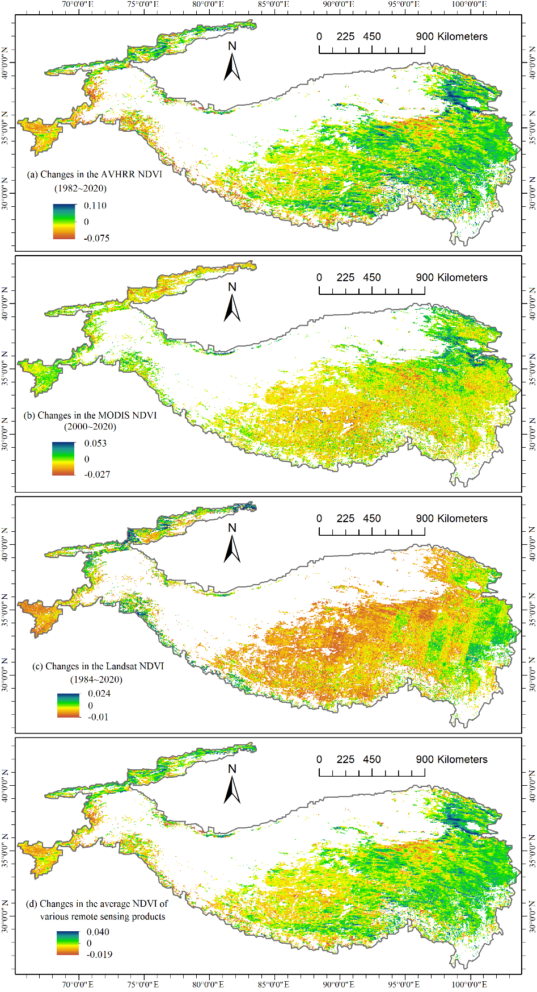

**Extended Data Fig. S1 | Changes in NDVI obtained by using different datasets in the alpine ecosystem of the Tibetan Plateau.** **a**, The 8-km bi-weekly NDVI data from Global Inventory Modeling and Mapping Studies (GIMMS) AVHRR during 1982–2020. **b**, The 1-km 16-day NDVI data from terra MODIS during 2000–2020. **c**, The 30-m 8-day NDVI data from USGS Landsat TM/OLI 8-Day NDVI Composite (Landsat 5, Landsat 7, and Landsat 8) during 1984–2020. **d**, The average changing rate of the three NDVI products.

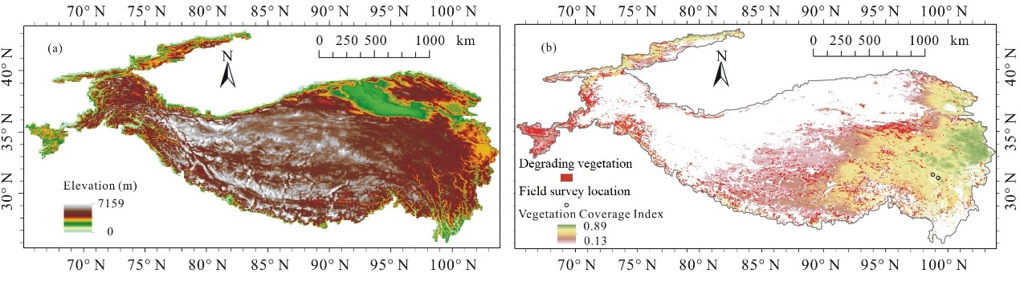

**Extended Data Fig. S2 | Basic topographical and vegetation conditions of the Tibetan Plateau. a**, The elevation gradients increasing towards the northwest. **b**, the corresponding vegetation cover gradient (shown by the 1982–2020 average VCI) decreasing towards the northwest of the Tibetan Plateau. The vegetation degrading areas are marked in **b**, in addition to the locations with sporadic dead birch observed in the field survey.

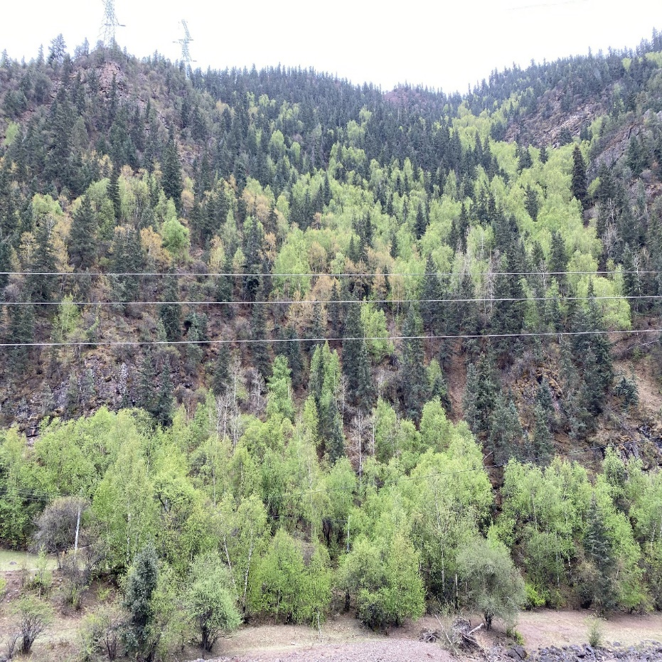

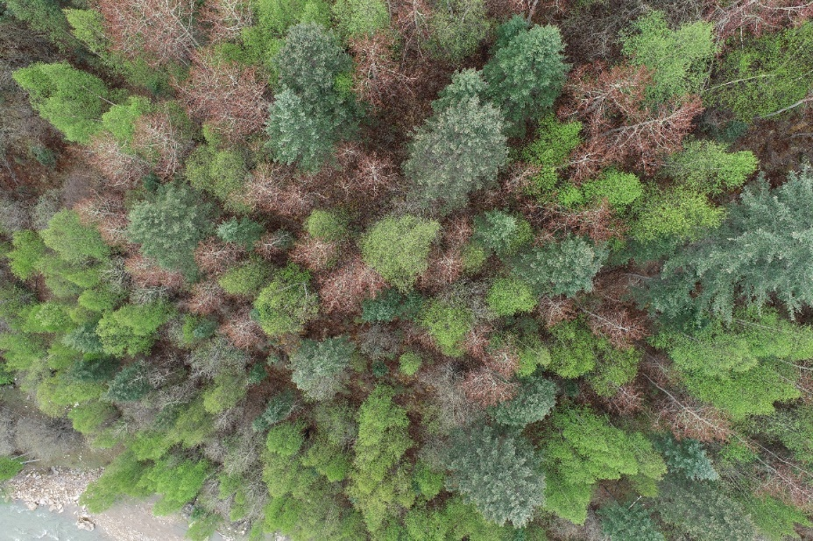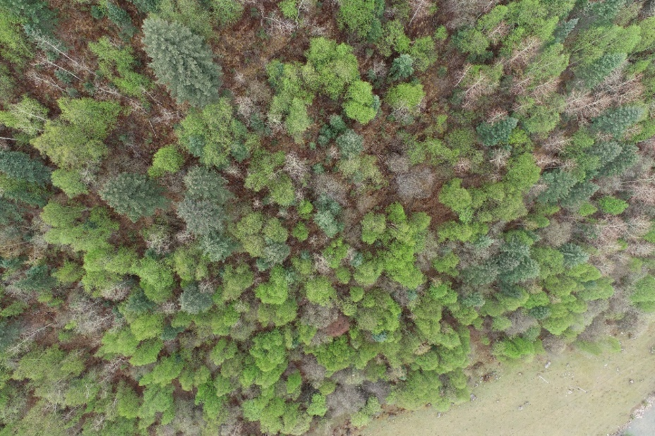

**Extended Data Fig. S3 | Photos of the forest with sporadic dead birch (*Betula platyphylla* Suk.) observed in Jiangda County during the field survey.** The locations seen in these photos are marked in Fig. S2b. **a**, horizontal view from the foot of the mountain. **b**, vertical view from the unmanned aerial vehicle.

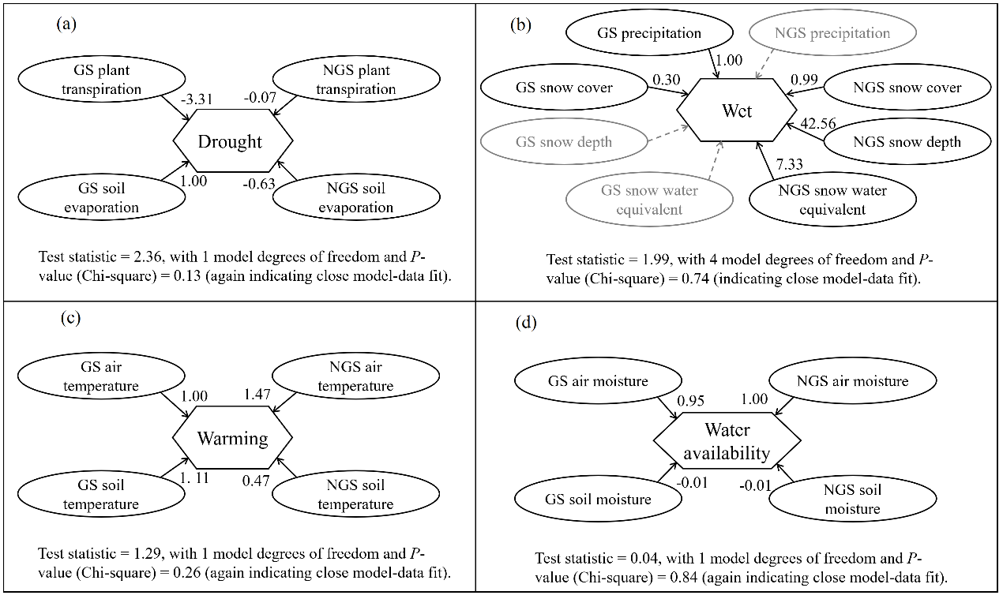

**Extended Data Fig. S4 | Construction of the model variables (i.e., latent variables of the SEM). a**, Drought. **b**, Wet. **c**, Warming. **d**, Water availability.

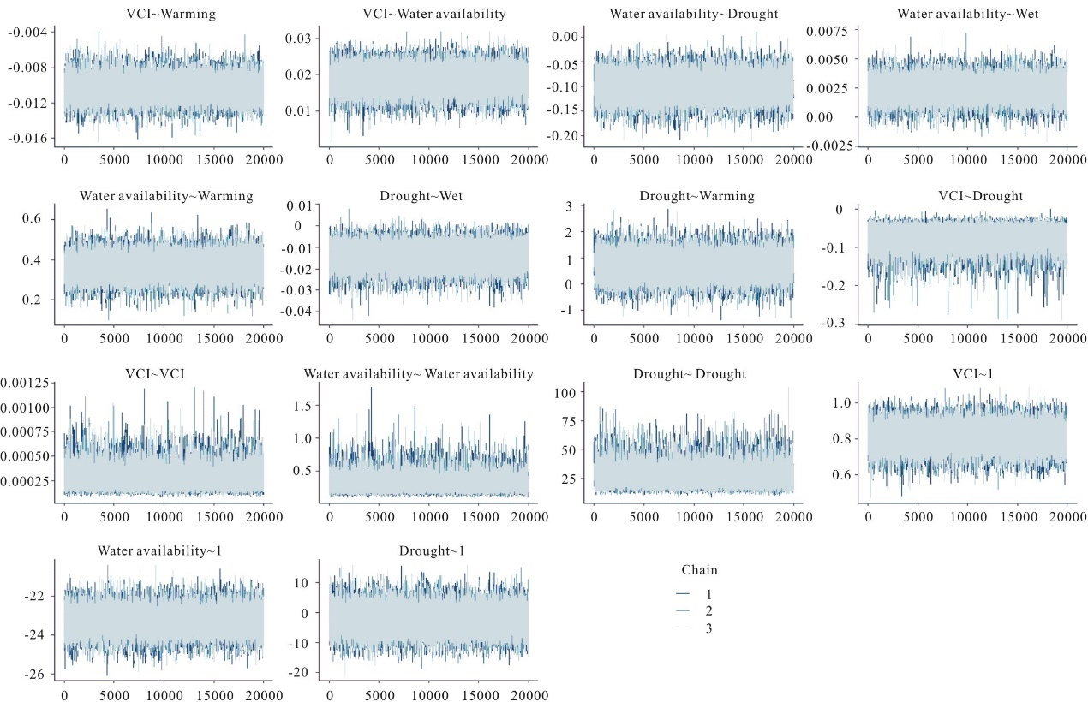

**Extended Data Fig. S5 | Convergence on the target posterior distribution of the SEM model.**